NOVEMBER 2019
THUNDERBIRD RESTAURANT DAILY DINNERSPECIALS
Available each day by 2:00 pm

 | Sunday | Monday | Tuesday | Wednesday | Thursday | Friday | Saturday
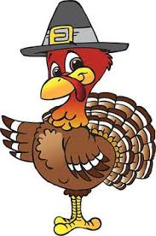 |  |  |  |  |  | 1  Calamari  Strips w/Fries  $12 | 2  Prime Rib  $19.50
Special | 3  Turkey Dinner  $12 | 4  BBQ Chicken  Wrap  $12 | 5  Twisted Chicken Tacos (3)  $8 | 6  WEEKDAY LUNCH SPECIALS AVAILABLE 11am-3pm  MONDAY: Corn Dogs (2) – N – Tots $6.50  TUESDAY: ½ Taco Salad $7  WEDNESDAY: Chili Dog $6  THURSDAY: Tuna Avocado Wrap $7  FRIDAY: Halibut Burger $7  Pork Chop  Dinner  $14 | 7  Salisbury Steak  $12 | 8  All You Can Eat  Fish-N-Chips  $17 | 9  Pot Roast  $12
Special | 10  Catfish Po Boy  w/Fries  $12 | 11  Sloppy Joe’s  w/Tots  $12 | 12  Hard or Soft Taco  2 for $10 | 13  Cordon Blue  w/Rice Pilaf  $18 | 14  Chicken Andouille Alfredo Linguine  $12 | 15  All You Can Eat  Spaghetti  $15.50 | 16  Prime Rib  $19.50
Special | 17  Turkey Dinner  $12 | 18  Supreme Flat Bread Pizza  $10 | 19  Twisted Chicken Tacos (3)  $8 | 20  Steak Stir Fry  $13 | 21  Stuffed Meatloaf  $14 | 22  Calamari  Strips w/Fries  $12 | 23  Pot Roast  $12
Special | 24  Turkey Dinner  $12 | 25  Sloppy Joe’s  w/Tots  $12 | 26  Hard or Soft Taco  2 for $10 | 27  Cordon Blue  w/Rice Pilaf  $18 | 28  CLOSED  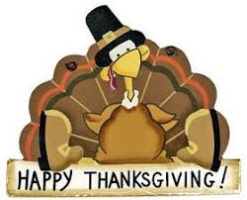 | 29  NY Steak  &  Eggs  $15 | 30  Prime Rib  $19.50

