Let Thunderbird Restaurant do the cooking for you.
Call-in Orders Welcome
JUNE 2017
7121 Waller Rd E
Tacoma, WA 98443
(253) 536-3162

 | Sunday | Monday | Tuesday | Wednesday | Thursday | Friday | Saturday
Special |  |  |  |  | 1  Pork Fried Steak | 2  Chicken Stir Fry | 3  Prime Rib
Soup |  |  |  |  | Navy Bean | Clam Chowder | Loaded Baked Potato
Special | 4  CFS Club Sandwich | 5  BBQ Crispy Chicken Salad | 6  Blue Cheese Monster Burger | 7  Indian Tacos | 8  Artichoke Spinach Stuffed Chicken | 9  Corn Beef & Cabbage | 10  Prime Rib
Soup | Navy Bean w/Ham | Chicken Noodle | Beef Barley | Santa Fe Chicken | Minestrone | Clam Chowder | Chicken Pot Pie
Special | 11  Cabbage Rolls | 12  Sirloin Steak & Crispy Onion Salad | 13  Baked Ziti | 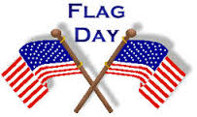  14  Indian Tacos | 15  Meatloaf | 16  BBQ Ribs Dinner | 17  Prime Rib
Soup | Steak & Mushroom | Chicken Tortilla | Tomato Basil | Eight Bean | Potato & Ham | Clam Chowder | Navy Bean
Special | 18  Corn Beef Hash | 19  Chicken Marsala | 20  Zesty Chicken & Orzo | 21  Indian Tacos | 22  Fried Chicken | 23  Pot Roast | 24  Prime Rib
Soup | Egg Drop Vegetable | Beef Barley | French Onion | Split Pea | Cabbage & Kielbasa | Clam Chowder | Loaded Baked Potato
Special | 25  Catalina Cranberry Chicken | 26  Grilled Jalapeno White Cheddar Bacon Burger | 27  Pistachio Chicken Salad | 28  Indian Tacos | 29  Sundried Tomato Sausage Penne | 30  BBQ Ribs Dinner | 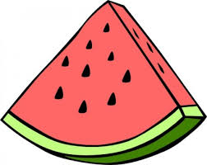
Soup | Navy Bean w/Ham | Corn & Andouille Chowder | 7 Bean | Minestrone | 8 Bean w/Ham | Clam Chowder

